Parking Map

Welcome to the Clayton Early Learning campus,
Parking is available on the East and West parking lot or along Martian Luther King Boulevard.

Parking Along Martin Luther King Blvd.
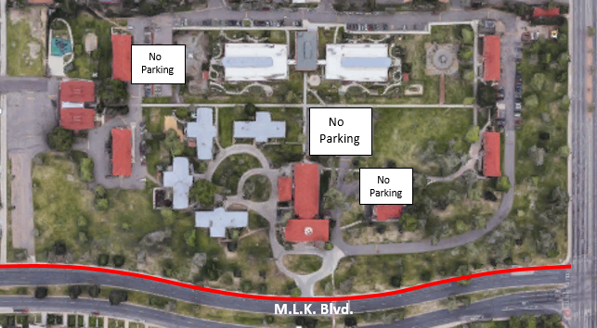

West Parking lots

- To access the Wests lot go West on Martin Luther King.
- Turn right on the second entrance just before Madison Street.

